Assignment 3 Report

GMLFA (AI60007) - Autumn,2024 - IIT Kharagpur

**Group 14**

Vinayak Mali Saurabh Jaiswal

24AI60R13 24AI60R46

October 17, 2024

Model Architecture

As instructed following is the model architecture

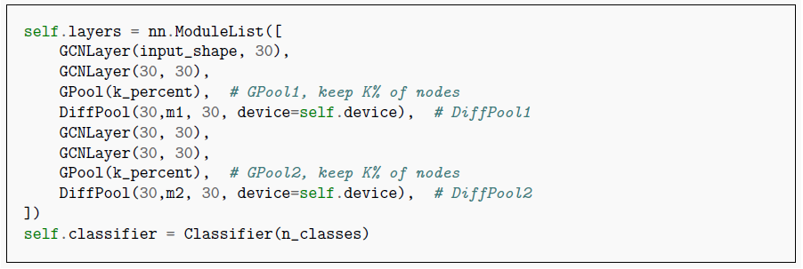

The model architecture consists of a series of graph convolutional layers (GCNLayer) that process node

features, followed by pooling layers (GPool) to retain a percentage of nodes (k percent). It incorporates

differentiable pooling (DiffPool) to aggregate information and reduce dimensionality, ultimately feeding the

output into a classifier to predict class labels.

Analysis of D&D - Binary Classification Task

**Final accuracy after 10 epoch with best_k 60% is : 77%**

If number of epochs will be increased then it will improve the accuracy too.

We are going to analyze the loss and accuracy results on following points:

• cluster size in pooling layer i.e. m1 and m2 values

• By changing number of epochs (taking less number of epochs for visualization)

For epoch = 3 m1 = 6 and m2 = 3

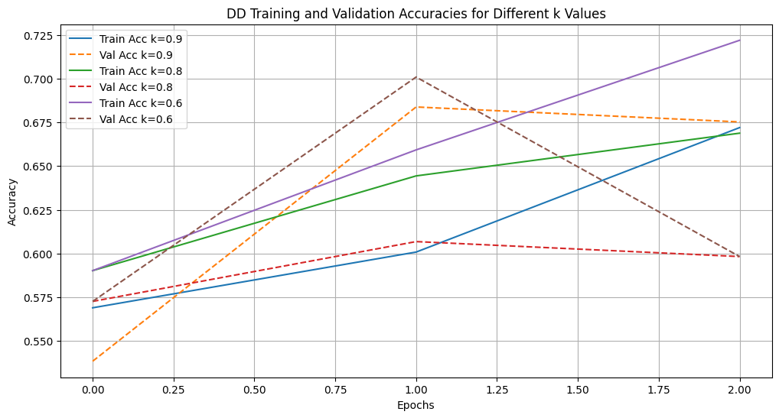

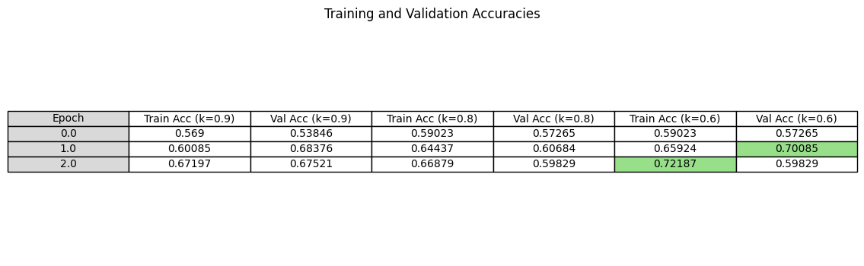

For epoch = 10 m1 = 6 and m2 = 3

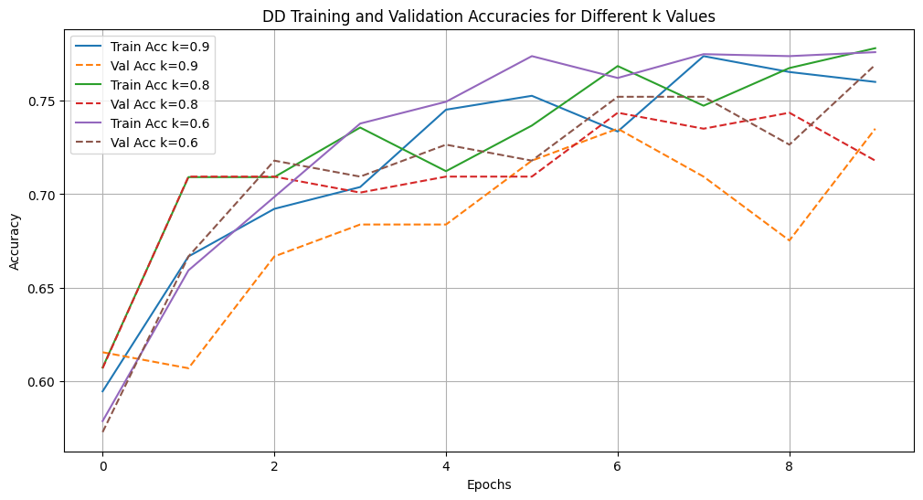

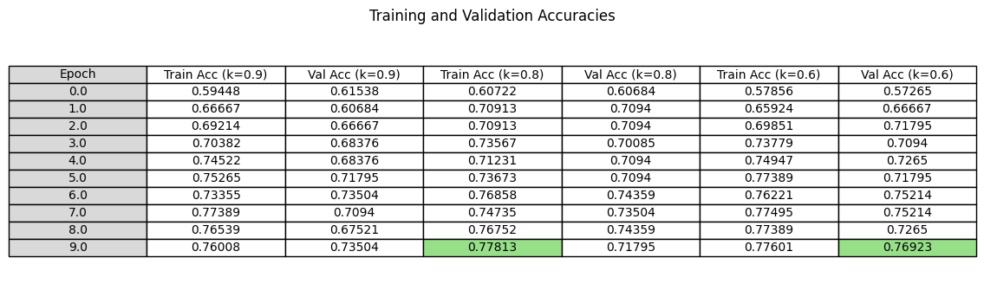

As epoch increase k = 60% is best for validation and this pattern not continues in much higher epochs

Analysis of ***ENZYMES*** - Binary Classification Task

**Final accuracy after 1000 epoch with best_k 90% is : 67%**

If number of epochs will be increased then it will improve the accuracy too.

We are going to analyze the loss and accuracy results on following points:

• cluster size in pooling layer i.e. m1 and m2 values

• By changing number of epochs (taking less number of epochs for visualization)

For epoch = 5 m1 = 6 and m2 = 3

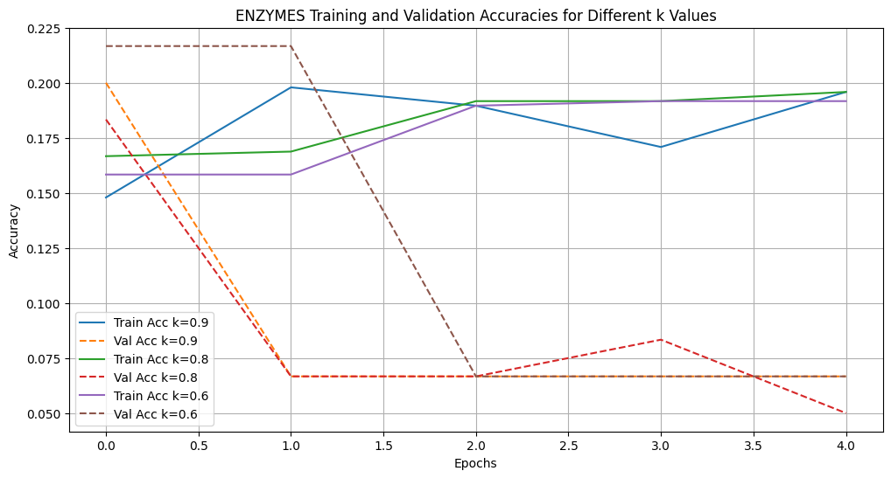

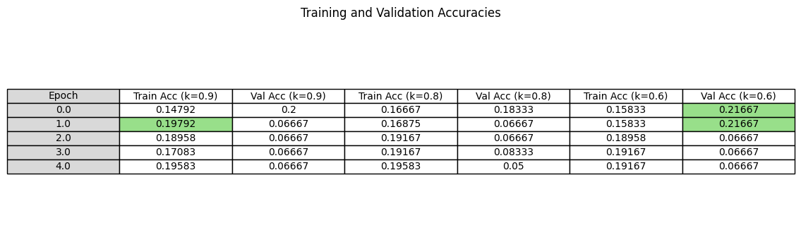This data table sis showing data for low number of epoch but from this we can understand that validation accuracy is very less compare to the train accuracy but after further analysis test accuracy is much better than validation accuracy. From data we can clearly see that validation accuracy is better for 60% k value in initial epochs and for train k value is 90% best.

For epoch = 10 m1 = 6 and m2 = 3

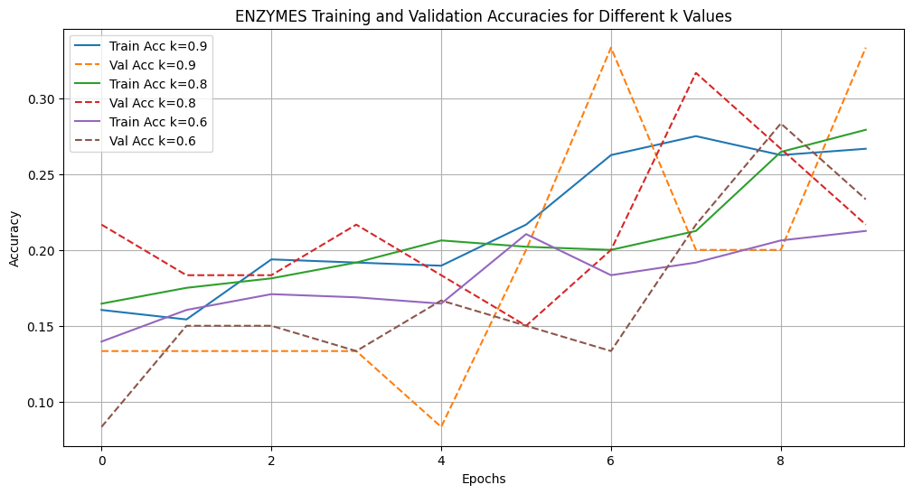

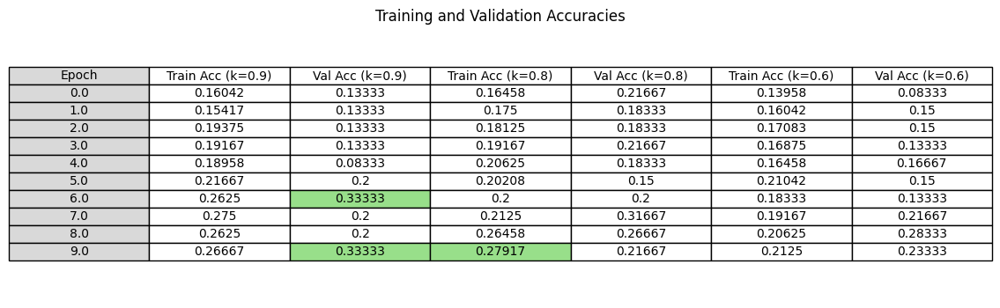

As epoch increase k = 90% is best for validation and this pattern continues in much higher epochs.

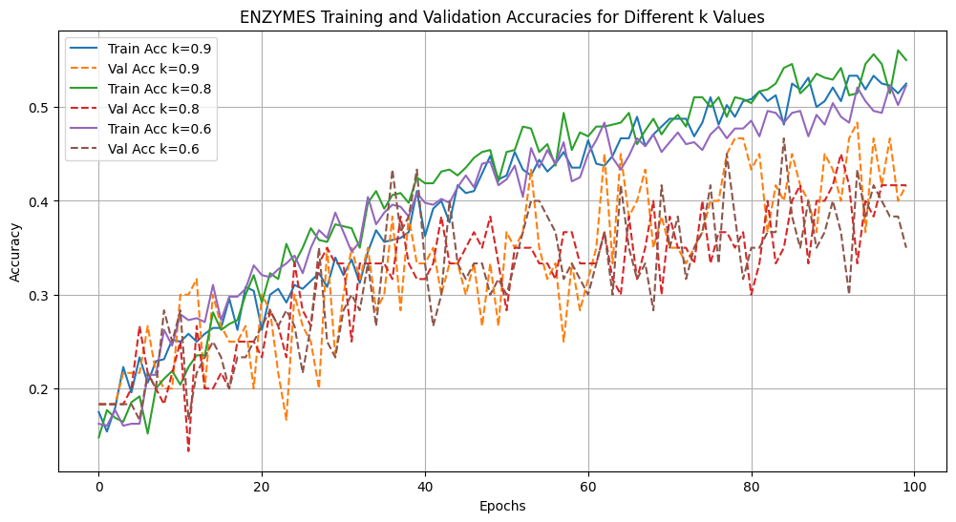For 100 epoch :